Project 2

The Card Matching Game

CIS-42829

Name: Matthew Yang

Date 6/5/16

Introduction

Title: Matching Card Game

This is a card matching game.

The cards are set before you, and the user needs to input two cards one at a time in order to reveal what number is underneath those two cards. The goal of the game is to pick two cards that have the same number underneath them.

When all cards are matched successfully, the game is over.

This is a fun family memory game that many play to see how fast they can finish the game in the least amount of turns.

Summary

Project size: 250 lines

Variables: there are 3 main variables that aren’t in an array, and there are 3 arrays with one having 26 variables, the second containing 13 variables, and the third containing 2 variables. Therefore, there are 44 main variables in all.

This project contains most concepts we have learned in class, I feel very good with this project since I found an easy way of displaying eliminated cards. I still could have added points if I figured out a clever way to do that as well.

Flowchart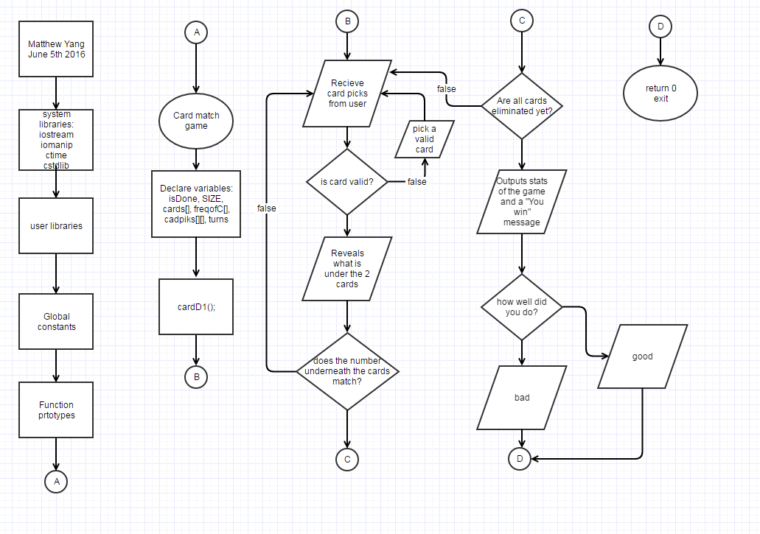

Major variables

Type Variable Name Description Location

|  |  |  |  |
| --- | --- | --- | --- |
| integer | SIZE | Number of cards (26) | In declared variables |
|  | turns | How many turns has passed | After cards that the user has inputted have been verified |
| Integer arrays | cards[ ] | Value in each card 1-13 | After the declaration of variables, and when the program reads the revealed values back to the user |
|  | freqofc[ ] | Used to make sure each card is picked only twice | After the declaration of variables |
|  | cadpiks[ ][ ] | User input to choose cards | Near the beginning of the do while loop |
| bool | isDone | Determines when to finish the game | At the end of main, inside the last for-loop |

Constructs

Chapter Keywords Location

|  |  |  |
| --- | --- | --- |
| Chapter 2 | * Data types: int, bool, string constants | * (in the major variables page) |
| Chapter 3 | * Iomanip: setw( ) * String | * In cardD1( ) function * In declaring variables section |
| Chapter 4 | * If statements * Switch statement | * Many of them everywhere * At the very end of main |
| Chapter 5 | * For loops * Do while loop * Increments | * After the declaring variables * After the first for loop * In every for loop and after verifying user inputs |
| Chapter 6 | * Function | * Before the computer asks for the user to input a card |
| Chapter 7 | * Arrays 1D and 2D | * (in the major variables page) |

Pseudocode

*creates randomness*

*create values for each card, while making sure each card is repeated only twice*

*makes sure that no card has the same value more than twice.*

*outputs the intro and rules to the game*

*displays virtual cards while marking X's on them if they are eliminated*

*pick card 1, and makes sure it is a valid number, (1-26 and not eliminated already)*

*pick card 2, and make sure it is a valid number.*

*makes sure that the cards you inputted are different.*

*outputs the results of the cards*

*counts the turn you are on*

*if the cards have the same number underneath them, they are eliminated*

*displays turn*

*sets card picks back to zero*

*counts the number of eliminated cards*

*displays the number of terminated cards*

*loops back to pick cards until you have eliminated all cards*

*finishes the program if 26 cards are eliminated, while displaying the total turns it took you to finish the game*

*tells you how well you did on the game*

Program

//declare variables

bool isDone = false; //determines when game is done

const unsigned int SIZE =26; //total #of cards

int cards[SIZE] = {0}; //total card's values

int freqofC[13] = {0}; //frequency of cards

int cadpiks[1][2]; //card picks

unsigned int turns=0; //turns used

unsigned seed = time(0); //creates randomness

srand(seed);

//create values for each card,

//while making sure each card is repeated only twice

for(int i=0; i<SIZE; ++i) {

int num = rand() % 13 + 1;

while (freqofC[num-1]>=2) { //makes sure that no card has the

num = rand() % 13 + 1; //same value more than twice.

}

++freqofC[num-1];

cards[i] = num;

}

//outputs the intro to the game

cout << "Hello!"<<endl<<

"This game is called the Card Matching Game. "<<endl<<endl<<\

"~~~~~~~~~~~~~~~~~~~~~~~~~~~~~~~~~~~~~~~~~~~~~~~~~~~~~~~~~~~~~"

"~~~~~~~~~~~~"<<endl<<endl<<

"The goal of the game is to eliminate all the cards"

" you see below,"<<endl<<

"which are numbered 1-26. All of which have one number underneath "

<<endl<<

"them from 1-13. These cards contain two of each number from 1-13."

<<endl<<

"You eliminate these cards by first picking two of the 26 cards on"

<<endl<<

"the screen, one at a time. Then, I will flip them over, and tell"

<<endl<<

"you what number is underneath them. If these two cards match, "

"then"<<endl<<

"they are eliminated from the game, "

"this will be indicated out loud,"<<endl<<

"and I will draw an X on the card. If these cards do not match,"

" then"<<endl<<

"they will simply be placed back as they were before I flipped "

"them."<<endl<<

"The game is over when all cards are eliminated,(when all cards "

"have"<<endl<<

"X's on top of them)."<<endl<<endl;

cout << "NOTE: To get the full experience of this game, do not scroll up to"

<<endl<<

"see what I said a card was on a previous turn, "

"this game is based on memory.";

cout << endl<<endl<< "~~~~~~~~~~~~~~~~~~~~~~~~~~~~~~~~~~~~~~~~~~~~"

"~~~~~~~~~~~~~~~~~~~~~~~~~~~~~"<<endl<<endl;

cout<< setw(23) <<"GAME START!"<<endl<<endl<<

"___________________________________"<<endl;

do{

cardD1(cards, SIZE); //displays virtual cards while marking X's on

//them if they are eliminated

cout<< endl;

//pick card 1, and makes sure it is a valid number,

//(1-26 and not eliminated already)

cout <<endl<< "Please pick your first card for the turn."<<endl;

cin >> cadpiks[0][0];

if(cards[cadpiks[0][0]]=0){

cout << "You have already picked that card. Please pick a card"

" that is on the board, and that does not have an X on it.";

cin >> cadpiks[0][0];

}

if (cadpiks[0][0]<1||cadpiks[0][0]>SIZE) {cout << "you must pick a card "

"that exists on the screen above, and that does not have an X "

"on it."<<endl;

cin >>cadpiks[0][0];

}

//pick card 2, and make sure it is a valid number.

cout << "Please pick your second card for the turn."<<endl;

cin >> cadpiks[0][1];

if(cards[cadpiks[0][1]]=0){

cout << "You have already picked that card. Please pick a card"

" that is on the board, and that does not have an X on it.";

cin >> cadpiks[0][1];

}

if (cadpiks[0][1]<1||cadpiks[0][1]>SIZE) {cout << "you must pick a card "

"that exists on the screen above, and that does not have an X "

"on it."<<endl;

cin >>cadpiks[0][1];

}

//makes sure that the cards you inputted are different.

while (cadpiks[0][0]==cadpiks[0][1]){

cout << "you must pick a number that is different than the first "

<<endl<<"card you have picked. Pick another card for your"

" second card."<<endl;

cin >>cadpiks[0][1];

}

//outputs the results of the cards

cout << endl << "Card number "<< cadpiks[0][0]<<" has a "<<

cards[cadpiks[0][0]-1]<<" under it." <<endl;

cout <<"Card number "<< cadpiks[0][1]<<" has a "<<

cards[cadpiks[0][1]-1]<<" under it." <<endl<<endl;

turns++; //counts the turn you are on

//if the cards have the same number underneath them,

//they are eliminated

if (cards[cadpiks[0][0]-1]==cards[cadpiks[0][1]-1]){ cout <<"Cards "<<

cadpiks[0][0]<< " and " <<cadpiks[0][1] <<" are eliminated."

<< endl<<endl;

cards[cadpiks[0][0]-1]=0;

cards[cadpiks[0][1]-1]=0;

}

//displays turn

cout << "That was turn number "<<turns<<"."<<endl<<endl;

cadpiks[0][0]=0; //sets card picks back to zero

cadpiks[0][1]=0;

int cnt=0; //counts the number of eliminated cards

for(int i=0; i<SIZE; ++i)

if( cards[i]==0 ) ++cnt;

if(cnt==26) isDone = true;

// displays the number of terminated cards

cout << "You have eliminated " << cnt << " cards out of 26." << endl;

}while(!isDone); //finishes the program if 26 cards are eliminated,

//while displaying the total turns it took you

//to finish the game

cout << "You have Won! you have completed the game in " <<turns<< " turns.";

cout << endl;

//gives special message if you had a perfect game

switch (turns){

case 13: cout << "WOW! A perfect game! You're amazing!!";

default: cout << "";

}

//tells you how well you did on the game if you did not have

//a perfect game

if (turns>13 && turns<=17){

cout <<"That was a pretty good game!";

}

if (turns>=18 && turns<22){

cout << "That was an OK game, although you can do better.";

}

if (turns>=22 && turns<=25){

cout << "Not a really good game. Try again another time?";

}

if (turns>25){

cout << "That was a bad game.";

}

cout << endl;

cout << "Thanks for playing!";

//Exit stage right!

return 0;

}

void cardD1(int cards[], int SIZE) {

string cad1P2= "| 1 |",cad2P2= "| 2 |",

cad3P2= "| 3 |",cad4P2= "| 4 |",

cad5P2= "| 5 |",cad6P2= "| 6 |",

cad7P2= "| 7 |",cad8P2= "| 8 |",

cad9P2= "| 9 |",cad10P2="|10 |",

cad11P2="|11 |",cad12P2="|12 |",

cad13P2="|13 |",cad14P2="|14 |",

cad15P2="|15 |",cad16P2="|16 |",

cad17P2="|17 |",cad18P2="|18 |",

cad19P2="|19 |",cad20P2="|20 |",

cad21P2="|21 |",cad22P2="|22 |",

cad23P2="|23 |",cad24P2="|24 |",

cad25P2="|25 |",cad26P2="|26 |",

cadP1="___", cadP3= "|___|";

if (cards[0]==0){cad1P2="| X |";} if (cards[1]==0){cad2P2="| X |";}

if (cards[2]==0){cad3P2="| X |";} if (cards[3]==0){cad4P2="| X |";}

if (cards[4]==0){cad5P2="| X |";} if (cards[5]==0){cad6P2="| X |";}

if (cards[6]==0){cad7P2="| X |";} if (cards[7]==0){cad8P2="| X |";}

if (cards[8]==0){cad9P2="| X |";} if (cards[9]==0){cad10P2="| X |";}

if (cards[10]==0){cad11P2="| X |";} if (cards[11]==0){cad12P2="| X |";}

if (cards[12]==0){cad13P2="| X |";} if (cards[13]==0){cad14P2="| X |";}

if (cards[14]==0){cad15P2="| X |";} if (cards[15]==0){cad16P2="| X |";}

if (cards[16]==0){cad17P2="| X |";} if (cards[17]==0){cad18P2="| X |";}

if (cards[18]==0){cad19P2="| X |";} if (cards[19]==0){cad20P2="| X |";}

if (cards[20]==0){cad21P2="| X |";} if (cards[21]==0){cad22P2="| X |";}

if (cards[22]==0){cad23P2="| X |";} if (cards[23]==0){cad24P2="| X |";}

if (cards[24]==0){cad25P2="| X |";} if (cards[25]==0){cad26P2="| X |";}

cout << " "<<cadP1<<setw(6)<<cadP1<<setw(6)<<cadP1<<setw(6)<<cadP1<<setw(6)

<<cadP1<<setw(6)<<cadP1<<endl;

cout <<cad1P2<<" "<<cad2P2<<" "<<cad3P2<<" "<<cad4P2<<" "<<cad5P2<<" "

<<cad6P2<<endl;

cout <<cadP3<<" "<<cadP3<<" "<<cadP3<<" "<<cadP3<<" "<<cadP3<<" "<<cadP3

<<endl;

cout << " "<<cadP1<<setw(6)<<cadP1<<setw(6)<<cadP1<<setw(6)<<cadP1<<setw(6)

<<cadP1<<setw(6)<<cadP1<<endl;

cout <<cad7P2<<" "<<cad8P2<<" "<<cad9P2<<" "<<cad10P2<<" "<<cad11P2<<" "<<

cad12P2<<endl;

cout <<cadP3<<" "<<cadP3<<" "<<cadP3<<" "<<cadP3<<" "<<cadP3<<" "<<cadP3<<

endl;

cout << " "<<cadP1<<setw(6)<<cadP1<<setw(6)<<cadP1<<setw(6)<<cadP1<<setw(6)

<<cadP1<<setw(6)<<cadP1<<endl;

cout <<cad13P2<<" "<<cad14P2<<" "<<cad15P2<<" "<<cad16P2<<" "<<cad17P2<<" "

<<cad18P2<<endl;

cout <<cadP3<<" "<<cadP3<<" "<<cadP3<<" "<<cadP3<<" "<<cadP3<<" "<<cadP3

<<endl;

cout << " "<<cadP1<<setw(6)<<cadP1<<setw(6)<<cadP1<<setw(6)<<cadP1<<setw(6)

<<cadP1<<setw(6)<<cadP1<<endl;

cout <<cad19P2<<" "<<cad20P2<<" "<<cad21P2<<" "<<cad22P2<<" "<<cad23P2<<" "

<<cad24P2<<endl;

cout <<cadP3<<" "<<cadP3<<" "<<cadP3<<" "<<cadP3<<" "<<cadP3<<" "<<cadP3

<<endl;

cout << " "<<cadP1<<setw(6)<<cadP1<<endl;

cout <<cad25P2<<" "<<cad26P2<<endl;

cout <<cadP3<<" "<<cadP3<<endl;

}